Dis-Can-Haida-Bear Mask-Miniature

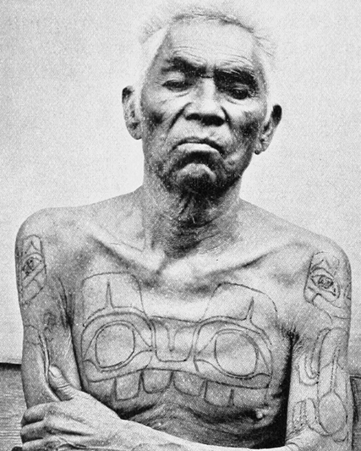

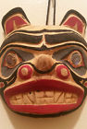

**Left: Haida Miniature Bear Mask. Right,** Portrait of Chief Xana showing his chest and arm Bear Clan tattoos from W.H. Collison, "In the Wake of the War Canoe," photographer uncredited, possibly **from Masset, Queen Charlotte Islands, ca July 1883, of the Bear Clan with Bear Clan Tattoos, in Youmans, William Jay, ed. 1898. *Appleton’s Popular Science Monthly*, LIII: 164. The Bear Clan Emblem used as a tattoo on Chief Xana eventually evolved into the use of the emblem on trade masks such as this miniature mask and into adornments of the body such as bracelets. The reason for this evolution of designs from being placed on the body to being worn on the body was because Christian missionaries in the 1880’s** placed shame on tattooing as being marks of the devil. By the 1890’s there were essentially no more events of Haida tattooing.

**Formal Label: Haida Miniature Bear Mask.**

**Accession Number:**

**LC Classification:**

**Date or Time Horizon:** Modern

**Geographical Area:** **Masset, Queen Charlotte Islands, July 1883.**

**Cultural Affiliation:** Haida

**Medium:** Cedar wood, red, black, gray and white paint.

**Dimensions:   
Weight:**

**Provenance: Artist**

**Condition: New**

**Discussion:** This mask is ofthe Bear God of the Haida of British Columbia, Kaiti. On the right is a shaman who had gained the right to have the Bear Clan emblem tattooed on his body during a Potlach. The rights to the Bear Clan Emblem was proprietary to the Bear Clan. The animal images and emblems used in the art and tattoos of the Haida people were linked to supernatural events in their history and the right to use the emblem was something that had to be conferred by the tribal group. In the myth of Kaiti, it was related that he took a high-ranking tribal woman as his wife, and she became a bear spirit herself. This story of an élite human’s transformation into a bear spirit is a story of shamanic conversion.

The origins of shamanic conversion of a human into a bear spirit is found in European Paleolithic cave art where negative hand prints were stenciled on cave walls by blowing a pigment over the hand of the shaman. Subsequently, these negative prints were slashed by the claws of a cave bear, symbolically linking the shaman with the bear. Among the earliest human altars are those of cave bear skulls set on rock pedestals deep inside the great caves, as though paying homage to a revered animal presence. This miniature mask is intended to convey the essence of the bear spirit of Kaiti.

The story of the Bear God, Kaiti, and his taking a human wife follows: A group of high-ranking women of a Haida village were gathering huckleberries, and in order to pacify a group of nearby bears the women were singing except one who, having stepped on some bear dung she began to curse the uncleanliness of bears. Two bears nearby heard her and decided they would not tolerate such insolence. They felt the disrespectful woman had to be punished. At the end of the day, as the berry-pickers headed home, the cursing one spilled her berries and was busy gathering them alone. Two brothers wearing bearskins approached her and one offered to help her if she would go with him. She agreed. This is the point where the human rationally consents to putting on the bear spirit as though in a marriage.

She followed them to a large house. Inside were several people, all of them were dressed in bearskins. One of them told her that she had been taken to a bear den and that she was now one of them. She looked down and found that she too was wearing a bearskin. The chief of the bear-people, Kaiti, took her as his wife, and she gave birth to twins which were half-human and half-bear. This is the point where humans must be able to put on the bear spirit in order to survive in the wilderness.

When the bear wife’s brothers came looking for her, they found her, and killed her husband, but before Kaiti died he taught her the songs that her brothers must use over his corpse to bring good luck and speed his soul to the afterlife. This is the point where the taking of an animal’s life by humans must be atoned for.

The half-human and half-bear sons lived with the tribe as humans until their mother died. Her death ended the twins' connection with humanity and they were transformed into bears and returned to live with the bear people. This is the point where the tribal group no longer has the vision to retain its bear spirit, and therefore the youth return to the wilderness to live as bears while the village loses its shamanic ability.

The transformation into a bear spirit in this story is associated with ancient Paleolithic shamanism that required humans to perfectly become like the spirit of a revered animal in order to survive in the wilderness. This suggests that there is a deep connection of the Haida myth with its origins in Paleolithic Eurasia, its art and its ancient spirituality.

**References:**

Rockwell, David. 1991. *Giving Voice To Bear*. Toronto, Ontario: Roberts Rinehart.

Shepard, Paul and Barry Sanders. 1985. *The Sacred Paw.* New York, NY: Arkana.